Question 1:
TCP (Transmission Control Protocol) and UDP (User Datagram Protocol) are both protocols for implementing the four-level communication hierarchy. Both are part of the Transport layer in the OSI model. Differences between TCP and UDP:
1. TCP sends a message to the destination telling it a message is about to be sent, then it waits for this message to be acknowledged before it starts to send the message. This establishes a connection before sending a message. UDP does no establish a connection before sending a message, it does not know if the destination is active.
2. TCP at the origin and the destination work together by acknowledgement and packet retransmissions to make sure all parts of the message are successfully sent. UDP does not.
3. TCP use both flow control and congestion control. TCP at the message origin can adjust its transmission rate to keep from overwhelming the destination TCP and to alleviate congestion between it and the destination.
Question 2:
Application Layer – Human-computer interaction layer. Ex: web browser
Presentation Layer – Ensures that data is in a usable format
Session Layer – Maintains connections, controls ports and sessions
Transport Layer – Transmits data using transmission protocols
Network Layer – Decides which physical path the data will take, breaks data in packets
Data Link Layer – Defines the format of data
Physical Layer – transmits raw bit stream over the physical medium

Question 3:
HTTPS is a secure version of HTTP. Encryption is a way of scrambling data so that only authorized parties can understand the information. This keeps communication between two parties secure, no one else can eavesdrop in the information.

Question 4:
A port is a software-defined number associated to a network protocol that receives or transmits data for a specific service.
A socket is one endpoint of a two-way communication link between two programs running on the network.
Email port numbers
SMTP – 465, 25
POP3 – 995,110
IMAP – 993, 143
Question 5:
If you connect to a public WiFi network anyone within range of your device can intercept everything you send or receive. This opens you to all types of attacks from information loss to malware distribution.
Question 6:
IPv4 address – 192.168.1.76

Question 7:
Ping is a computer utility which helps to determine if a destination on the Internet is active. This program returns how long it took to receive a response from the destination.
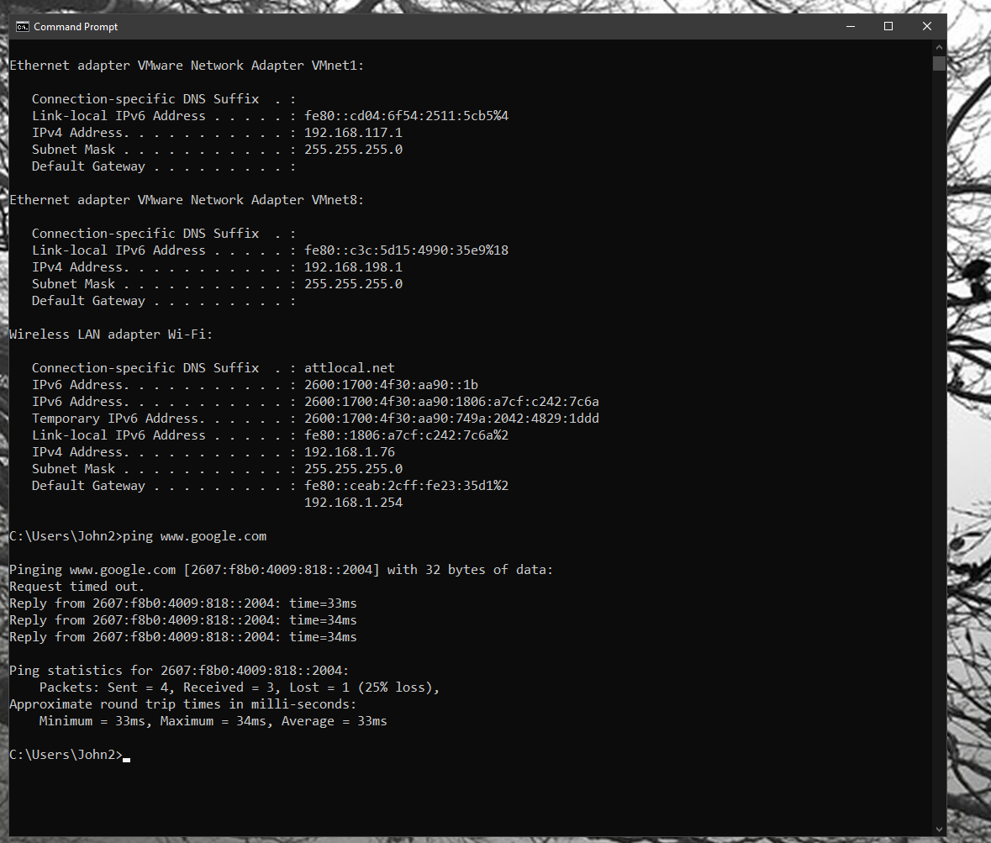
Question 8:
a. 2.4 GHz and 5 GHz
b. 2.4 GHz – 20 MHz and 5 GHz – 80 MHz
c. . 2.4 GHz – 20 MHz and 5 GHz – 80 MHz
d. yes
e. no
Question 9:
1. 200 is OK
2. 404 is Not Found
3.
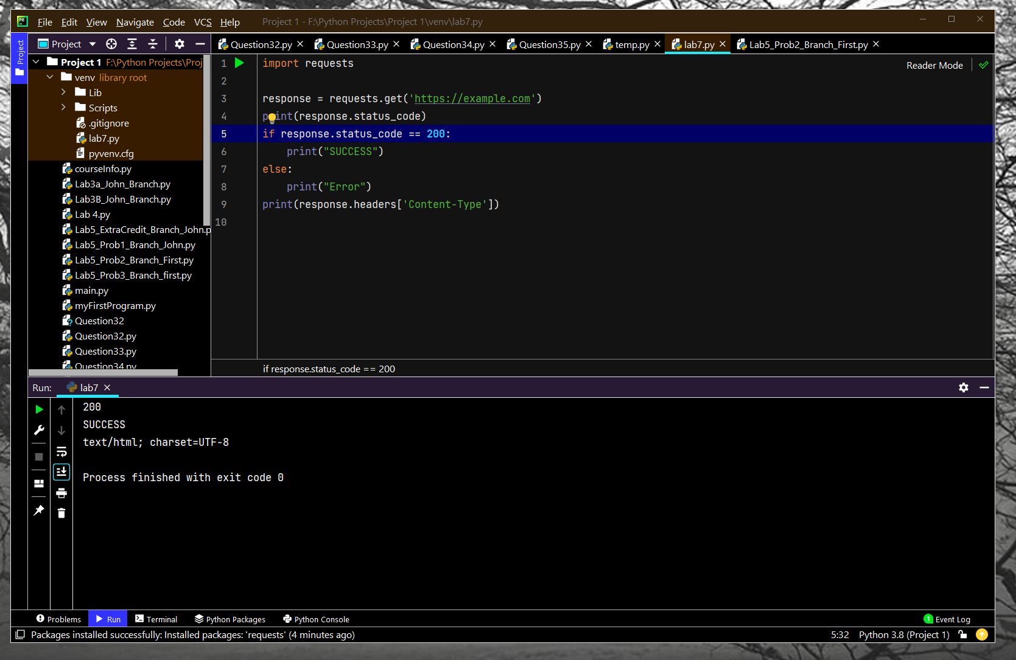

4.
